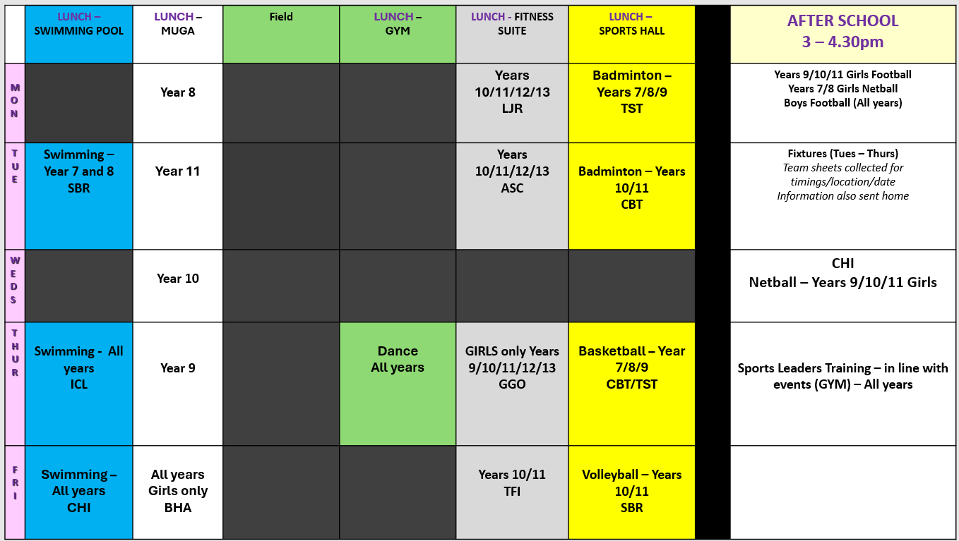
The Warriner School PE Department Extra-Curricular – Start date: 2nd March. End date: 27th March 2026

