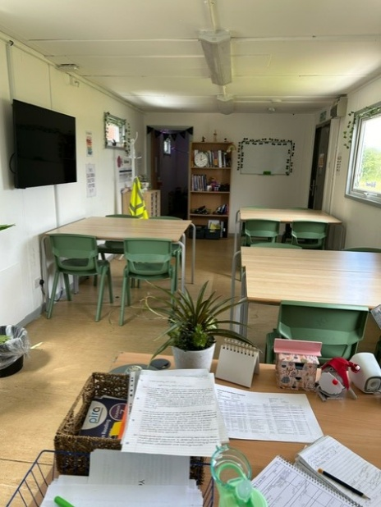
‘The Link’ Provision
This provision within The Warriner school was set up as a direct consequence of lockdowns enforced due to Covid-19. Many young people have since presented with a higher level of school based anxiety, with those suffering greatest sometimes school refusing.
Aim of Provision: To provide a space in school in which students who are unable to attend can come and access support in order to reintegrate back into school.
Entry: The Link aims to support those students who find it impossible to get across the threshold of mainstream lessons and access their learning alongside the rest of the cohort. Students with this profile are raised with key staff and parents/carers/guardians of those students considered are contacted to discuss The Link being accessed as a supportive measure to encourage reintegration back into the school setting.
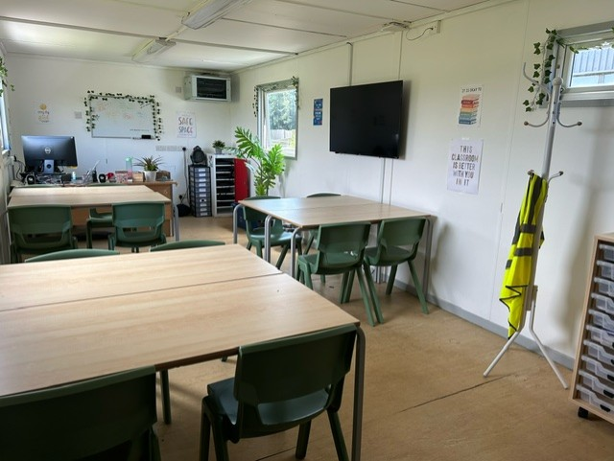
Setting: The Link is a small, inviting space with room for a maximum of 12 students. Laptops, headphones and textbooks are available for use by all students; and students each have a drawer in which to store work when not taken home. The Link sits upon the periphery of the school site, and this allows for students to journey straight to the space without having to negotiate the rest of the site. All students follow a tailored timetable, personal to them, as agreed in collaboration with the core team of staff overseeing the provision. The aim is to rebuild students’ access to learning and in many cases, ultimately, lessons. Steps towards this long-term goal are small and sustainable.
The Link is led Ms Tompkins, our Integration Attendance Provision Lead. Subject teachers from English, Maths and Science run weekly lessons in The Link supporting students with their learning of the core curriculum and it provides students with the opportunity to interact with additional members of staff and therefore improve confidence and interpersonal skills key to their personal growth. Our Attendance Officer, Miss Lowe, and our SENCO, Mr Jones, oversee the provision that The Link provides

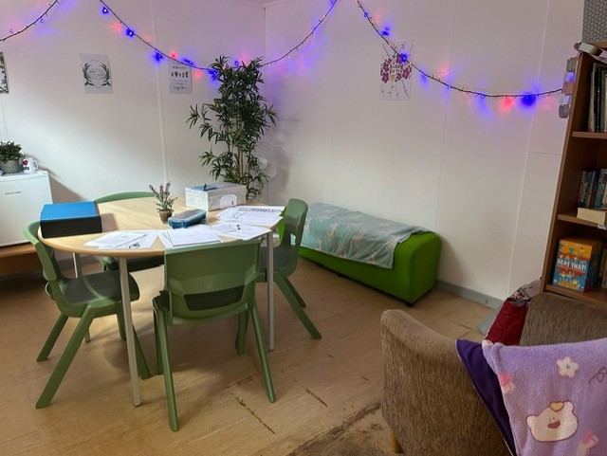
Curriculum: The provision is set up to enable all students’ individual needs to be met. Students can stream lessons from the room, therefore following the timeline of the main cohort. Bespoke curriculum mapping is also available to students to cater for with differing levels of need. Whilst academic progress is of course significant, the focus of this provision is to support young people to not only access their education but also the world around them. This provision, therefore, has a large focus on the pastoral, personal side to learning and, a bespoke, stripped-down curriculum experience is necessary; particularly in the first instance.
A weekly farm session may be included in the timetable. It provides a quiet, expansive space for students to move their bodies, take a ‘brain break’ and interact with the farm animals, as well as farm staff. Our farm team would support with these sessions and students enjoy getting more hands on with the animals, alongside learning about the environment. These sessions are a positive way to improve self-esteem and interpersonal skills, whilst creating a sense of community amongst the students.
Progression and Exit Pathways: There are several pathways available to students when it is conducive to their personal progress to access some or all of their learning outside of The Link. Amendments to personal timetables will happen incrementally, having met with, and discussed proposed steps with parents/carers/guardians. Pathways are as follows:
- Lessons - Some students who access The Link feel ready to re-join lessons. Timetables are RAG rated in order to identify more and less ‘do-able’ lessons and students choose to access those more ‘doable’ in the first instance. Ms Tompkins liaises directly with students’ teachers and a reintegration plan will be agreed upon and communicated in advance of any student making a transition back to lessons.
- Study Zone - The purpose of Study Zone is always on learning and reintegration back into mainstream lessons where possible. Study Zone Manager, Mrs Shaffner is experienced and will liaise closely with Subject Leaders and teachers to ensure work set is appropriate which may include live streaming. In Key Stage 4 students complete GCSE work in Study Zone lessons. In Key Stage 3 students access work and support in curriculum areas.
- Nurture mentor group – Students may join one of our nurture mentor groups, which are a SEND provision based within the Aspire department. They are vertical tutor groups allowing for mixed year group peer support and friendships. The activities each morning mirror that of mainstream tutor time provision but time is also allowed for support of any anxieties or concerns for the day.
- Mainstream school - where possible, upon successful completion of any combination of the above provision, students would return to mainstream education and a full timetable. This decision will be agreed with student, parent and key staff.

