The Warriner School Post Results Services – GCSEs, BTEC Level 2 Qualifications
If you are concerned about an examination result, please discuss your results with a member of staff in the first instance. Members of staff will be available in 6th Form on the morning of results. Any queries regarding results after this time should be sent to exams@warriner.oxon.sch.uk. A request for a copy of the marked paper (Access to Scripts) or for a review of marking (RoM) can be made by scanning the QR codes below.
Please note the following:
- Written consent from the student is required before any result enquiries are made and fees will apply for most services.
- Fees must be paid in advance of any application being processed. Bank details are as follows:
  - Reference – Student name and subject
  - Account name – The Warriner School
  - Sort code – 30-90-42
  - Account number - 39606768
- The school reserves the right to request reviews prior to payment if necessary.
- Marks and subject grades may be lowered, remain the same or raised.
Full details of our Post Results Policy can be found on The Warriner School website along with JCQ Infographic and Fees and Deadlines. The Warriner School - Examinations
The JCQ post-results services currently available are detailed below.
Access to Scripts (ATS) FOC for the following purposes:
• Copies of scripts to support reviews of marking and teaching & learning
Any other requests will incur a £5 per paper admin fee.
Reviews of Results (RoRs):
• Service 1 (Clerical re-check) - This service checks that the script has all been marked and totalled correctly.
• Service 2 (Review of marking) – An independent reviewer examines the original marking to identify any errors in the original marking. An administrative error review is automatically included. Reviewers will not re-mark the script.
• Service 3 (Review of moderation) - This service is not available to an individual candidate.
Appeals:
• The appeals process is available after receiving the outcome of a review of results
Awarding bodies will only accept requests for reviews of marking from centres and not from candidates or their parents.
POST-RESULTS SERVICES: DEADLINES, FEES AND CHARGES Summer 2026 series
The post-results services available are:
- Reviews of Results (RoRs): Clerical re-check; review of marking; review of moderation; Appeals
- Access to scripts (ATS): Access to marked examination scripts
GCSE and BTEC Level 2 Qualifications – Please note charges are per paper
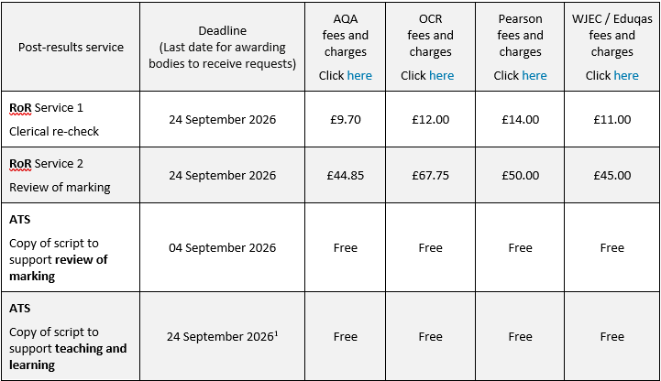


Consent Forms



