Supporting your child's school attendance

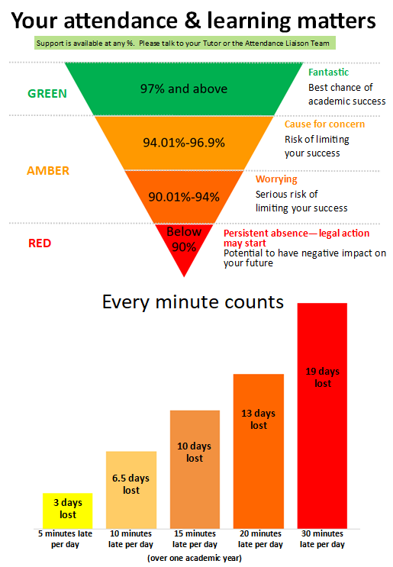
It is a legal obligation of all parents/carers to ensure their child attends school regularly and punctually, in a good condition to learn. Showing your child the importance of attending school every day not only helps your child to settle quickly when starting school but helps them to keep and maintain friendships and enjoy the school environment.

We expect students to attend school unless they are ill and absence from school should be avoided whenever possible. We do not have a 48 hour sickness rule, so it is at parental discretion when a student is well enough to return.

We understand that some appointments during the school day are unavoidable i.e. with hospital specialists. However, appointments where there is flexibility such as dental appointments, doctor’s appointments or eye tests should not be scheduled during the school day.

The law gives NO entitlement to parents to take their child on holiday during term time.

There tends to be good reasons why children become reluctant to attend school. Take the time to listen to your child, share any concerns you or your child may have with the child’s tutor or our Attendance Liaison Team, Ms Lowe (r.lowe@warriner.oxon.sch.uk) and Ms Timms (h.timms@warriner.oxon.sch.uk) and seek support at the very earliest opportunity.

More information is available on our school website - https://www.thewarrinerschool.co.uk/page/?title=Attendance&pid=133

If your child is absent you must inform us of the reason by 8:30am. Please call 01295 720777 or email awar1788@warriner.oxon.sch.uk. If your child is absent without explanation this could result in a home visit.

Signed by parent/carer/guardian ………………………………………….. Date …………………………

