LIFE IN NAZI GERMANY 1919-1945 REVISION BOOKLET:

Below are statements from the exam board which explain what you are meant to know. Self assess your current knowledge and use this as a starting point for your revision.

Knowledge statements | Understanding (1=poor; 5=excellent)
Knowledge statements | 1 | 2 | 3 | 4 | 5
The Weimar Republic includes its problems and successes and how these relate to the formation of the Nazi party.
The Spartacists,
the terms of the Treaty of Versailles and reactions to this within Germany:
the Kapp Putsch,
the formation of the National Socialist party.
Challenges and recovery includes the key events of 1923, including the invasion of the Ruhr, hyperinflation and the Munich Putsch;
the work of Stresemann in aiding recovery of the Weimar Republic between 1924 and 1929, including the introduction of a new currency, the Dawes and Young Plans and Germany’s entry to the League of Nations.
Increasing support for the Nazi Party involves the support from different social groups in the years to 1929
including changes of tactics, the appeal of Hitler, the role of propaganda, the work of the SA and the economic and political consequences for Germany of the Wall Street crash of 1929.
The creation of the Nazi state involves the reasons why Hitler was able to gain total power in Germany,
the role of von Papen and von Hindenburg in 1932–33
the key events of 1933–4: the Reichstag Fire, the Enabling Act, the banning and removal of rival power groups including political parties, trade unions and the Night of the Long Knives.
The nature of Hitler’s role as Fuhrer.
the role of the SS, concentration camps and local wardens;
laws restricting civil liberties;
churches and opposition groups and individuals
the role of Goebbels
The purpose and effectiveness of different types of propaganda, for example films, posters, rallies.
Opposition and resistance involve its nature and extent, including the significance of the White Rose Group and Pastor Niemoller.
Nazi policies towards young people and women;
the nature and purpose of education in schools for boys and girls
the role and effectiveness of youth movements including preparation for war, charity work and military role in the war years.
The emergence of rebel groups, for example the Edelweiss Pirates.
The role of women within the family, society and employment, and changes to their role during the period
The impact of economic policies to reduce unemployment: the New Plan, labour service, construction of autobahns and rearmament.
Changes in the standard of living for German workers, Strength Through Joy.
The importance of Nazi beliefs in Aryan supremacy and the ‘master race’.
The treatment of minority groups, for example Jews, gypsies and disabled people.
The changes in policies during the period and the escalating discrimination and persecution including the Nuremberg Laws and Kristallnacht up to and including the ‘final solution’.

TIMELINE

Use your notes to create a overview timeline of the period. Try and remember some key dates!

DATE | KEY EVENT(S)
1918

1919

1920

1921

1922

1923

1924

1925

1926

1927

1928

1929

1930

1931

1932

1933

1934

1935

1936

1937

1938

1939

1940

1941

1942

1943

1944

1945

KEY TERMS:

Read through the key terms below. If you cannot explain a word make sure you find out a definition

Key term | Definition
Article 48
Aryan
Autarky
Beauty of Labour
Block Warden
Concordat
Confessional Church
Dawes Plan
Dictatorship
Eidelweiss Pirates
Eugenics
Euthanasia
Four Year Plan
Fuhrer
Gestapo
Holocaust
Hyperinflation
Indoctrination
Jew
Lebensborn Program
NSDAP
Kaiser
Kapp Putsch
Kristallnacht
Lebensraum
League of Nations

Mein Kampf

Munich Putsch

New Plan
November Criminals

Nuremberg Laws

Police State

Putsch

New Plan

Night of the Long Knives
Rechsarbietdienst
Reichstag
Reparations
Ruhr
Propaganda
Proportional Representation
SA
Social Darwinism
Spartacists
SS
Strength through Joy (Kdf)
Totalitarian
Wall Street Crash
White Rose Group
Year of crisis
Young Plan

The Weimar Republic includes its problems and successes and how these relate to the formation of the Nazi party.

Read the statements and tick whether they are examples of problems or successes

Statement | Problem | Success
Many ordinary Germans did not agree with the decision of politicians to sign a peace agreement
Ordinary Germans did not want the Kaiser to abdicate and wanted him back
Germany became a member of the League of Nations in 1926
A new currency was created called the Rentenmark-this stopped hyperinflation
Culture flourished in Weimar Germany-for example, cabaret
1923 became known as the Year of Crisis.
The Year of Crisis involved hyperinflation; the occupation of the Ruhr and the Munich Putsch
Radical groups like the Spartacists and the Friekorps tried to seize power
Proportional Representation was very fair and democratic-many countries use it today
Proportional Representation led to coalition governments that squabbled and could not agree-not much was achieved
In 1924 the Dawes Plan was signed. This led to US loans to Germany; the German economy recovered.
In 1929 the Wall Street Crash led to American loans being withdrawn. The economy crashed.
Millions lost their jobs after the Wall Street Crash.
Many had no faith in the Weimar politicians-they were known as ‘November Criminals’.
Reparations-the money Germany had to pay back under the Treaty of Versailles-depressed the economy.
Article 48 has become known as ‘the backdoor to dictatorship’. This was a weakness in the constitution which meant the President could suspend democracy in an ‘emergency’.
Gustav Stresemann helped the country to recover after 1923 as Chancellor and later Foreign Minister.

The Spartacists

Who were the leaders of the Spartacist revolt?_______________________________
____________________________________________________________________________________________________________________________________________________________________________________________________________

Complete the mind map below using your notes to explain why the revolt failed:

Leadership
Tactics
Why did the Spartacist revolt fail?

Organisation
Freikorps

How did the defeat of the Spartacists still end up making the Weimar government look weak?_______________________________________________________________________________________________________________________________________________________________________________________________________________________________________________________________________________________________________________________________________________

The Weimar Republic: Create a mind map on the Weimar Republic

THE WEIMAR REPUBLIC
THE RECOVERY
CULTURE
ECONOMIC PROBLEMS
THE WEIMAR CONSTITUTION
THE YEAR OF CRISIS
THE TREATY OF VERSAILLES

the terms of the Treaty of Versailles and reactions to this within Germany:

The terms of the Treaty of Versailles can be easily remembered using the mnemonic LAMB. Make sure you are aware of the different terms of the treaty by filling in the table below.

Term | Key details:
Land
Army
Money
Blame

the Kapp Putsch

Fill in the details on the Kapp Putsch below:

Who did it involve?
When was it?
Why was it important?

the formation of the National Socialist party.

Complete the speech bubbles to explain how the Nazi party was formed
Who was Gregor Strasser and what was the DAP?
What was Hitler doing when he got involved with the party?
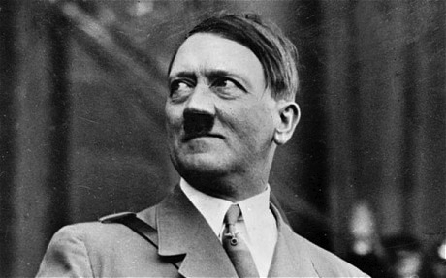

What did Hitler do during World War One?

Who designed the Swastika?

Challenges and recovery includes the key events of 1923

What happened during 1923? Summarise the events in the table below:

EVENT OF 1923 | KEY DETAILS:
OCCUPATION OF THE RUHR
HYPERINFLATION
THE MUNICH PUTSCH

The Munich Putsch of 1923:

The statements below are all positives and negatives associated with the Munich Putsch. Copy them onto the table below:

16 Nazis were killed | Hitler realized he would have to seize power legally | Hitler became famous
Nazis realized with Hitler they could not be successful | Hitler was imprisoned in Landsberg jail | Nazis ideas were spread by the Newspapers
The Munich Putsch failed | Hitler got the chance to write his book Mein Kampf (My Struggle) | People realized what a great speaker Hitler was
Hitler got a fairly lenient sentence | The Nazis were leaderless without Hitler | Leading Nazis fled abroad

The Munich Putsch was a failure: | The Munich Putsch was a success:

The work of Stresemann in aiding recovery of the Weimar Republic between 1924 and 1929, including the introduction of a new currency, the Dawes and Young Plans and Germany’s entry to the League of Nations.

Gustav Stresemann was instrumental to the recovery of Weimar Germany. Read the statements and copy them onto the speech bubbles to explain how Stresemann helped Germany

This helped Germany because it ended hyperinflation and brought confidence in the new currency.
Many Germans felt this was important because Germany was being acknowledged as a great power and being respected.
This helped Germany because money started pouring into Germany from America. This got the economy going and provided jobs and growth. Germans were much happier.
This brought stability to Germany because Germany’s borders had now been agreed.

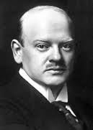
How did joining the League of Nations help?
How did the new Rentenmark currency help?
How did the Dawes (1924) and Young (1929) plans help?
How did the treaty of Locarno help?

Increasing support for the Nazi Party involves the support from different social groups in the years to 1929

Use your notes to fill in the speech bubbles for each group, explaining why they supported the Nazis.



WORKERS

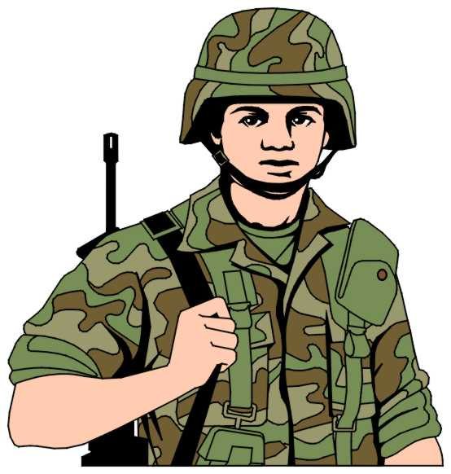

SOLDIERS

THE MIDDLE CLASSES



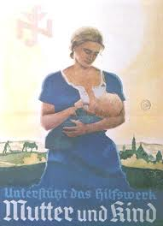

WOMEN



SHOPKEEPERS

Including changes of tactics, the appeal of Hitler, the role of propaganda, the work of the SA and the economic and political consequences for Germany of the Wall Street crash of 1929.

Complete the mind map on how Hitler became Chancellor to address these key areas you need to know:

Political reasons why Hitler became chancellor
Social reasons why Hitler became chancellor
Economic reasons why Hitler became chancellor
Nazi tactics and the role of Hitler

HOW DID HITLER BECOME CHANCELLOR?

POLITICAL REASONS

HOW DID HITLER BECOME CHANCELLOR?
NAZI TACTICS AND HITLER
ECONOMIC REASONS

SOCIAL REASONS

The creation of the Nazi state involves the reasons why Hitler was able to gain total power in Germany and the role of von Papen and von Hindenburg in 1932–33

Complete the speech bubbles explaining why von Papen and Hindenburg appointed Hitler chancellor

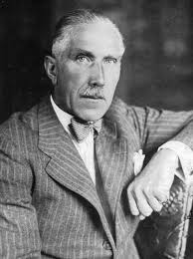
I, von Papen, helped Hitler become chancellor because …

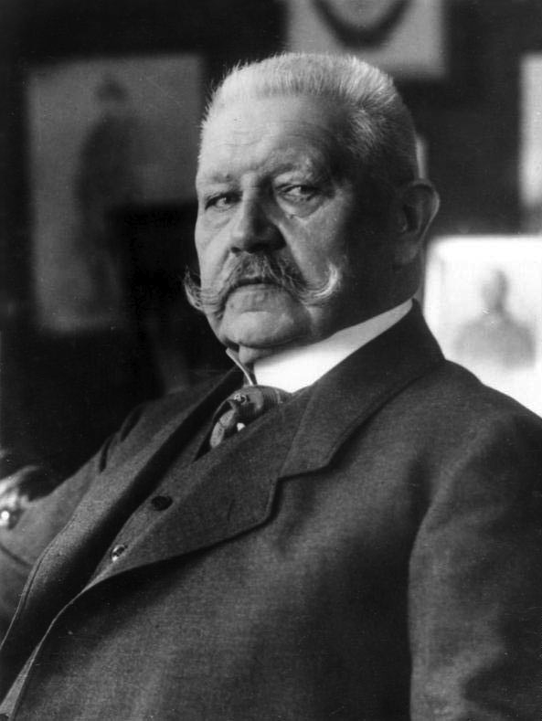
I, Hindenburg, helped Hitler become chancellor because ...

the key events of 1933–4: the Reichstag Fire, the Enabling Act, the banning and removal of rival power groups including political parties, trade unions and the Night of the Long Knives.

One way of remembering the key events is to use the mneumonic REMENDA. Fill in the table below explaining (a) what happened? (b) why it is important?

 | (a) What happened? | (b) Why is it important?
Reichstag Fire
Date:
Emergency Decree
Date:
March Elections
Date:
Enabling Act
Date:
Night of the Long Knives
Date:
Death of Hindenburg
Date:
Army Oath of Loyalty
Date:

the role of the SS, concentration camps and local wardens;

Complete the gap fill exercise on the SS or Schutzstaffel

The SS was the most powerful and sinister element of the Nazi movement. Originally formed in 19___________, it was turned into a formidable private army by Heinrich _______________. The SS were expected to show complete _______________to the Fuhrer. The SS were also the racial __________________ of the Nazi Party.

MISSING WORDS: obedience; elite; 1925; Himmler

Below is a list of SS departments. Fill in the table matching the department to the job described-use your notes to help you.

The SD
The Gestapo
Waffen SS
Death’s Head Units

SS Department | Job
 | Formed by Himmler in 1934. It was the intelligence arm of the SS with the special task of maintaining the security of the Fuhrer, party leadership, Nazi Party and Reich. It had the power of arrest, detention and execution.
 | Responsible for the extermination of the Jews as the German army advanced through Eastern Europe. Also responsible for the concentration camp system.
 | Undertook the role of a secret police force. Became the most important element in the state’s security system. Played a key role in eliminating opposition through creating an elaborate terror regime.
 | By 1939, it had a membership of 23,000. Established as a ‘second army’ by Himmler. From 1938, took direct responsibility for the war against the Jews.

laws restricting civil liberties

Below are examples of laws that were passed to restrict freedoms Germans had (civil liberties). Write them in the table below and tick how far you feel they restricted civil liberties.

- 7th April 1933, Jews were banned from jobs in the civil service and the legal profession

- 7th April 1933, Nazi officials were put in charge of all local government in the provinces.

- On May 2nd 1933, trades unions were abolished, their funds taken and their leaders put in prison. The workers were given a May Day holiday in return.

- 15th September 1935, the Nuremberg Laws were passed. Jews were deprived of their Citizenship. Marriages and sexual relations between Jews and Germans were outlawed.

- On July 14th 1933, a law was passed making it illegal to form a new political party. It also made the Nazi Party the only legal political party in Germany.

Law | Details | How far did the law restrict civil liberties?
 |  | 1 | 2 | 3 | 4 | 5

churches and opposition groups and individuals

Complete the gap filling exercises below:

What was the Concordat? What religion did it relate to?

For the leaders of the Catholic Church, the most important priority in 1933 was to secure their position. The ________________ was signed in 19______________ which guaranteed religious _____________to the church and the right to have a key role in __________________. In return, Hitler was guaranteed that the Church would not interfere in _____________________.

MISSING WORDS: Freedom; Education; Concordat; 1933

What was the German Christian Church? What religion did it relate to?

The Protestant churches were united in an all embracing German _______________ Church under Ludwig ________________ as National __________________. The church was dominated as much by Nazi ideas as by Protestantism.

MISSING WORDS: Bishop; Muller; Christian;

Use your notes to help you fill in key details on individuals we need to remember:

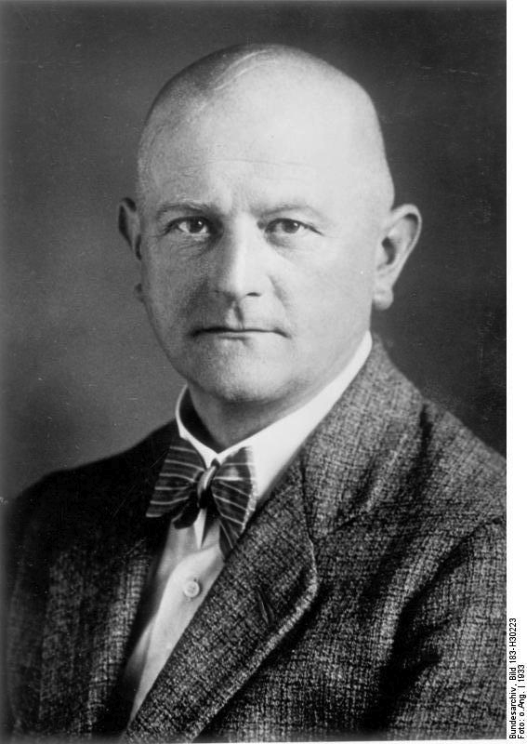 | 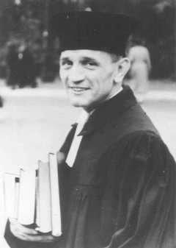
Ludwig Muller: | Martin Niemoller:
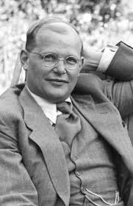 | 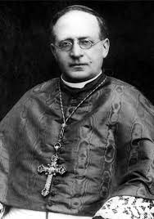
Dietrich Bonhoffer: | Pope Pius XI

The role of Goebbels
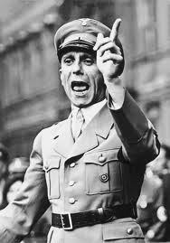
Read the paragraph below on Josef Goebbels and highlight key words and facts about him.

‘Goebbels joined the Nazi Party in 1925. He soon became the party’s expert on propaganda. He invented the ‘Hitler Myth’, publishing pamphlets and organizing demonstrations and election campaigns. In January 1933 he was appointed Minister of Propaganda and Popular Entertainment. He immediately took control of newspapers, films, radio and the arts. Goebbels was a master of publicity, carefully exploiting the Recihstag fire in February 1933., the burning of books in May 1933 and the Berlin Olympics of 1936. He was the author of the Nurmeberg Laws of 1935 and the Kristallnacht attack on the Jews in November 1938. He also organised the ‘Eternal Jew’ exhibition in Berlin and produced the anti-semtic film Jud Suss in 1937.

Now complete the questions on Goebbels below:

What events did I organize?
What jobs did I do?

When did I join the Nazi party?
What did the job of propaganda involve?

The purpose and effectiveness of different types of propaganda, for example films, posters, rallies.

PROPAGANDA EXAMPLE | PURPOSE | EFFECTIVENESS: What is good about it? How does it work? What are the drawbacks?
FILM: For example, Jud Suss
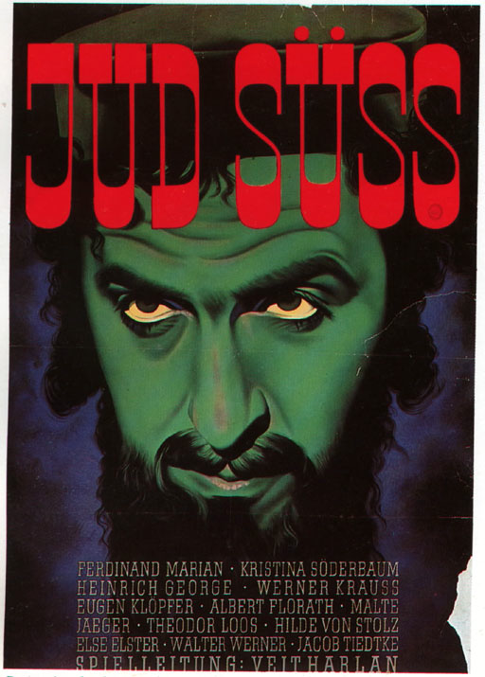

POSTER:
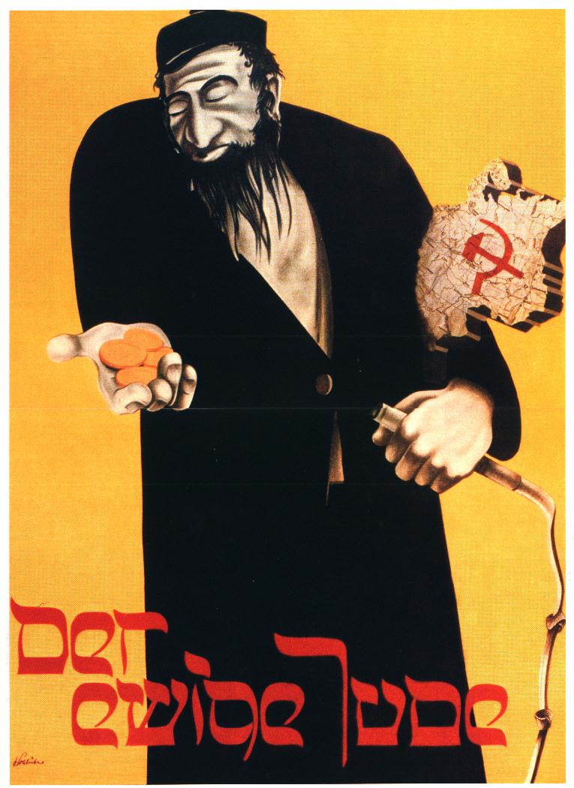

RALLY:
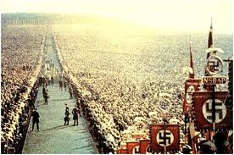

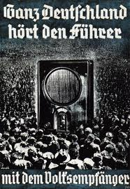
RADIO

Opposition and resistance involve its nature and extent, including the significance of the White Rose Group

Read the paragraph on the White Rose Group below:

Various youth groups attempted to resist the regime. Hans and Sophie Scholl led Munich students in the ‘White Rose’ group which distributed anti-Nazi leaflets and sought to sabotage the German war effort. In 1943, the Scholls led an anti-Nazi demonstration in Munich. As a result they were arrested by the Gestapo, tried and executed in February 1943.

Nazi policies towards women;

What were the three K’s?________________________________________________
____________________________________________________________________________________________________________________________________________________________________________________________________________

Read the statements and identify whether they are true or false:

Statement | True | False
In 1933, nearly all the 19,000 female civil servants in government lost their jobs.
From 1936, no women could serve as a judge
Women were encouraged to marry by marriage loans of 1000RM from 1933
In 1933, a Mother’s Cross was introduced to reward mothers. A woman with four children received a bronze; with six a silver cross; eight a gold cross.
Women were strictly controlled in Weimar Germany

Read the facts below and then answer the question below:

Many woman were happy to stay at home; get married and have children. | Between 1933-39, the number of women in work increased. | Women had to go back to work because of labour shortages due to conscription and rearmament. | From 1937 young women had to do a Duty Year on farms.

To what extent did the Nazis achieve their goal of controlling women as mothers and wives?______________________________________________________________
________________________________________________________________________________________________________________________________________________________________________________________________________________________________________________________________________________________________________________________________________________________________________________________________________________________

the nature and purpose of education in schools for boys and girls

Fill in the table below to explain subject’s boys and girls studied and why the Nazis wanted them to study them.

BOYS |  | GIRLS
SUBJECT | WHY WAS IT STUDIED? | SUBJECT | WHY WAS IT STUDIED?

Why did girls and boys study different subjects?______________________________
________________________________________________________________________________________________________________________________________________________________________________________________________________________________________________________________________________

the role and effectiveness of youth movements including preparation for war, charity work and military role in the war years.

Use your notes to explain key details about the youth groups in the table below. Explain how effective you think each group were

HITLER YOUTH (BOYS) | BDM (GIRLS)
Key details: | Key details:
How effective? | How effective?

The emergence of rebel groups, for example the Edelweiss Pirates.

Write a paragraph on who the Eidelweiss Pirate were and why they are important:___
________________________________________________________________________________________________________________________________________________________________________________________________________________________________________________________________________________
________________________________________________________________________________________________________________________________________________________________________________________________________________________________________________________________________________
________________________________________________________________________________________________________________________________________

The impact of economic policies to reduce unemployment: the New Plan, labour service, construction of autobahns and rearmament.

KEY FACTS

NEW PLAN

THE NAZI ECONOMY

THE FOUR YEAR PLAN

KEY INDIVIDUALS

The changes in policies during the period and the escalating discrimination and persecution including the Nuremberg Laws and Kristallnacht up to and including the ‘final solution’.

Using your notes create a poster on Nazi policies and ideas towards the Jews and other groups. Pay attention to the success criteria below:

Success Criteria:

- Explains laws passed against the Jews and other minorities
- Explains attitudes and ideas towards minority groups
- Explains Kristallnacht
- Explains the Final Solution and what happened

PRACTICE EXAM QUESTIONS

A good way to revise is to write practice answers. Have a go at the practice questions below-I will be more than happy to mark them!

Practice comprehension questions (4 marks):

- Usually the first question you answer
- Worth 4 marks
- Don’t spend more than 5 minutes on these types of question
- You need to explain what you can learn
- To get full marks make sure you make an inference-an inference is what is suggested by the source. Make sure you back up your inference with evidence from the sources!

Mark Scheme:

LEVEL | MARK | DESCRIPTOR
1 | 1-2 | Simple statement  Student provides relevant examples from the sources or generalised unsupported comment about change.
2 | 3-4 | Developed statement  An inference about change is made and supported, based on the use of both sources.

Practice 9 mark questions:

- No introduction is needed
- Spend about 10 minutes on this type of question
- Ideally you will have two to three paragraphs
- Don’t forget PEA

QUESTION 1: The boxes below show two actions taken against German Jews. Choose one and explain how it affected the lives of Jews living in Germany.

The passing of the Nuremberg Laws in 1935 | Kristallnacht (The Night of the Broken Glass) 1938

QUESTION 2: Choose one and explain its importance in challenging the government of the Weimar Republic.

The Spartacist Revolt | The Kapp Putsch

QUESTION 3: The boxes below show actions taken by Stresemann. Choose one and explain how it helped Weimar Germany to recover in the 1920s.

The introduction of a new currency (the Retenmark) in 1923 | The Dawes Plan (1924) and the Young Plan (1929)

Mark Scheme:

LEVEL | MARK | DESCRIPTOR
1 | 1-3 | Generalised answer is offered with little specific detail.  Answer offers comment about importance that could apply to either individual, or general comment about specific person.
2 | 4-6 | Relevant details are offered but the link to the question is left implicit.  Answer provides information about the individual
3 | 7-9 | Analysis of importance.  The work of the individual is placed in a wider context in order to assess its impact and importance.

QUESTION TYPE: THE 12 MARK QUESTION

- Spend 15 minutes on this type of question
- Three paragraphs
- A conclusion-especially if it is a how far question

QUESTION 1: In what ways were the Nazis able to control the Churches in Germany? (12)

1933: The Reich Church was set up
July 1933: The Concordat was signed
1937: Pastor Niemoller was sent to a concentration camp

QUESTION 2: In what ways did the lives of women change in Nazi Germany in the years 1933–39? (12)

1933: Law for the Encouragement of the Marriage of Women
Domestic Science was taught to girls
1936: There was a shortage of workers in Germany

QUESTION 3: In what ways did the Nazis’ treatment of the Jews change in the years 1938–45? (12)

November 1938: German Jews and property were attacked during Kristallnacht (Night of the Broken Glass)
1939: The beginning of the Second World War
1942: The use of Zyklon B gas at Auschwitz

THE TWO PART QUESTION

- Another 9 mark question-see before
- A 16 mark question-you need to write a proper essay here
- Make sure you have an introduction and conclusion
- Make sure you include a most important reason
- You need to use PEA
- You need to spend approximately 25 minutes on the 16 mark question

QUESTION 1:

- In what ways did the Nazi Party try to increase its popularity in the years 1924–29? (9)
- ‘The problems facing the Weimar government in 1923 were caused by the Treaty of Versailles’. Do you agree? Explain your answer.

You may use the following in your answer and any other information of your own.
The Weimar Constitution used proportional representation.
1922: Germany fell behind with reparations payments.
1923: A loaf of bread cost 100,000 million marks.

QUESTION 2:

- Describe Goebbels’ role as Minister of Public Enlightenment and Propaganda. (9)
- ‘The use of terror was the most important reason for Hitler’s rise to total power in the years 1933–34’. Do you agree? Explain your answer. (16)

You may use the following in your answer and any other information of your own.
January 1933: Hitler was appointed Chancellor of Germany.
March 1933: The first Nazi concentration camp opened at Dachau.
August 1934: Death of President Hindenburg.

QUESTION 3:

- Describe the effects of hyper-inflation on Germany in 1923. (9)
- ‘The Wall Street Crash was the most important reason for the increase in support for the Nazis in the years 1928–32.’ Do you agree? Explain your answer. (16)

You may use the following in your answer and any other information of your own.
1928: The Nazis had less than 3% of the vote
1932: A Nazi election poster had the caption ‘Hitler – Our Last Hope!’
1932: Unemployment in Germany reached 6 million

QUESTION 4:

- Describe the effects of the Reichstag Fire in February 1933 on Hitler’s rise to power. (9)
- ‘The use of propaganda was the main reason for the lack of opposition to Nazi rule.’ Do you agree? Explain your answer.

You may use the following in your answer and any other information of your own.
Cheap radios were made available
1933: Dachau concentration camp opened
The ‘Strength Through Joy’ organisation arranged holidays for workers

QUESTION 5:

- Describe the Nazi party’s beliefs on Aryan supremacy and the ‘master race’. (9)
- ‘Germans benefited from rising living standards in the years 1933–39’. Do you agree? Explain your answer. (16)

You may use the following in your answer and any other information of your own.
1933: Six million Germans were unemployed.
During the 1930s 7,000 km of motorways were built.
1935: The Reich Labour Service was introduced.

QUESTION 6:

- Describe the role of the SS in the years 1933–45. (9)
- ‘The Munich (Beer Hall) Putsch was a total failure for the Nazi Party’. Do you agree? Explain your answer. (16)

You may use the following in your answer and any other information of your own.
9 November 1923: Hitler marched into Munich with 3,000 Nazis.
During his trial, Hitler was on the front page of many German newspapers.
1925: The Nazi Party was re-launched.

