Attendance Newsletter – June 2025


Welcome to our Attendance Newsletter

We will be sending out certificates to parents/carers this week for excellent and improved attendance for last term (Term 5). And students will also be receiving house points.

This is the first week of our new incentive for this term. Students will be competing in a Wimbledon themed incentive and the winning mentor group from each year will be receiving an ice cream from the ice cream van that will be coming into school on the last day of term!!



Attendance Matters

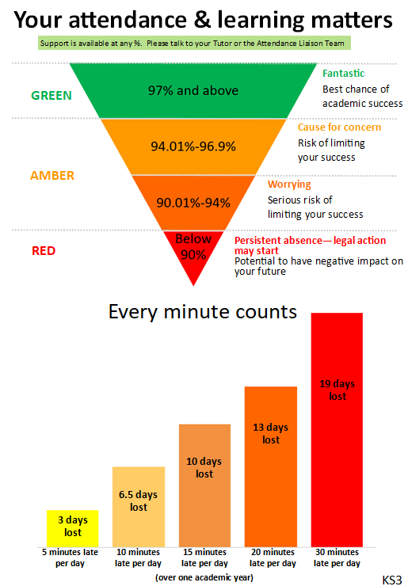
We continue to regularly track student attendance and make contact home where we have concerns. It is not only important learning and personal development that your child misses, but also opportunities to be with their peers and build friendships. Please ensure your child attends school unless they have a genuine reason for absence.

We welcome contact from parents/carers if you have concerns around school attendance – please contact one of our Attendance Liaison Team

Attendance Officer, Beccy Lowe (r.lowe@warriner.oxon.sch.uk)
Attendance Support Worker, Hazel Timms (h.timms@warriner.oxon.sch.uk)
Attendance Lead, Julia Jackman (j.jackman@warriner.oxon.sch.uk).

Please also refer to the Attendance pages of the school website where we have lots of attendance information and links to external support - https://www.thewarrinerschool.co.uk/page/?title=Attendance&pid=133

Thank you for your support.

