Looking for Potential Rowers on the South Coast‌ ‌ ‌ ‌ ‌ ‌ ‌ ‌ ‌ ‌ ‌ ‌ ‌ ‌ ‌ ‌ ‌ ‌ ‌ ‌ ‌ ‌ ‌ ‌ ‌ ‌ ‌ ‌ ‌ ‌ ‌ ‌ ‌ ‌ ‌ ‌ ‌ ‌ ‌ ‌ ‌ ‌ ‌ ‌ ‌ ‌ ‌ ‌ ‌ ‌ ‌ ‌ ‌ ‌ ‌ ‌ ‌ ‌ ‌ ‌ ‌ ‌ ‌ ‌ ‌ ‌ ‌ ‌ ‌ ‌ ‌ ‌ ‌ ‌ ‌ ‌ ‌
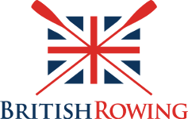

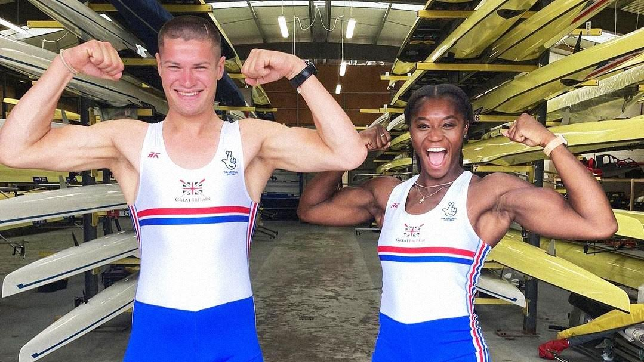

Looking for Potential Rowers in and around Oxford

Dear Mr Warriner and Miss MacLachlan,

I am writing to you to let you know about an event that will be running at Hinksey Lake in Oxford by Hinksey Sculling School at the start of the summer holidays, specifically Tuesday, Wednesday and Thursday 25-27th July. We are looking to find young athletes who have what it takes to potentially make it into the GB Rowing Team racing at the World Championships and Olympic Games.

This event will be free of charge, last around ninety minutes, and allow your students to come down to a club and experience the sport first hand. It will involve assessments to measure their physical attributes and strength, as well as a short taster session on the water.

Height brings a big advantage in rowing, so ideally girls should be at least 176cm (5’9”) and boys at least 188cm (6’2”) tall. This will generally mean that we are looking for students in Years 9 to 13. I stress that no prior rowing experience is necessary. We are looking for athletes who may currently be playing a different sport, such as rugby, netball, volleyball, basketball or swimming, but who have the right build and physicality to succeed at rowing.

Please could you pass the message on to any student you know of who fits the bill and may be interested? To book a place, they can contact me directly, copying in a parent or guardian, via ben.reed@britishrowing.org. Moreover, if there is some way of getting this information out to parents more widely, such as via PE department social media or a school weekly newsletter, that would be really helpful. We have found that parental input increases uptake significantly. (If someone is interested but cannot make one of these days - I realise that many people will head abroad as soon as schools break up - please ask them to still get in touch and we can arrange an alternative.)

Finally, can I also bring to your attention that British Rowing has a team in place dedicated to helping schools set up and run in-house indoor rowing, both with equipment and advice? If this is something you would be interested in investigating, please email Dan Hetherington (dan.hetherington@britishrowing.org).

Likewise, British Rowing has a paralympic team, which has so far won 50% of all the gold medals in rowing at the Paralympic Games since 2008. Some disabilities to qualify for this are obvious, such as those that fill the 'arms-only' and 'trunk-and-arms-only' categories, but there is a third 'whole body' category for which disabilities can easily be overlooked, such as visual impairment, nerve damage or fused bones. If you have a student who you think might classify in this way, please contact Will Stockton (will.stockton@britishrowing.org) to discuss things further.

Many thanks for your help in this matter,

Ben Reed

Sign Up

